**Remote Control Redesign**

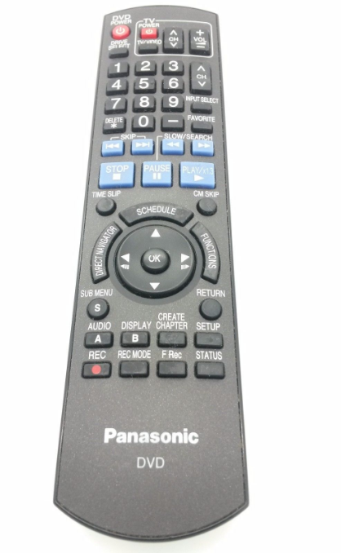

The Problem:

This remote offers many functions and tries to show all the functions on one remote, which is overwhelming. Of the few quality DVD players still on the market, this is one of the few that allows the user so much control over their recording with editing, documenting for archiving and multiple viewing modes.

**PRO USER:**

Usually in an industry that still deals with DVD editing and or recording of DVD’s.

Needs/Desires/Expectations: Wants a way to easily edit, title, and manipulate recorded material in the simplest quickest way possible.

Habits: Records for multiple hours weekly and fills orders (customized DVD’s) for clients.

Main complaints about current model:

1. There is no QWERTY keyboard so inputting and editing window titles is very time consuming and frustrating.

2. Using the multiple rewind and FF speeds can confuse the remote and many times user ends up passing their desired location.

**BASIC USER:**

They are not interested in the more complex functionality offered with this remote and prefer not to even see it- they can’t imagine who would use those functions.

Habits: They get their other media mostly from their digital devices but still have some old movies/family vids on DVD that they like to watch occasionally.

Needs/Desires/Expectations:

This user wants to use the basic functions of the device. They just want to watch a DVD.

Habits: They get most of their media interaction from the internet and don’t want to be bothered with complex remotes or visually overwhelming remotes.

**Proposed Sollution:**

A multi-view cell app that is used as a remote. One for basic user view and one for Pro user view.

Features of Basic User:

Power

Rewind/FF

Play/Stop

Features of the Pro user:

Power

Rewind /FF with different speeds (jog shuttle)

Play/Stop

Input Select

Return

Direct Nav (window screen)

Enter

Function (Finalize DVD)

Record

Added a Qwerty keyboard to facilitate labeling and titling.

Make FF and REW buttons into a jog shuttle for easier control in cueing tapes.

The rest of the buttons on the original remote are NEVER used!!